Rahul Pharma SQL Analysis

User Story ID: US 01
Title: Tender Status Monitoring
Business Problem
- The Tender Manager wants to monitor tender performance and maintain a good win ratio.

Business Question
- How many tenders were submitted??
SQL Query
SELECT COUNT(*) AS Total_Tenders
FROM tender_master
Result
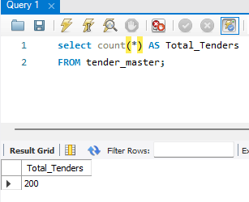
Business Insight
- A total of 200 tenders were submitted during the reporting period.
Recommendation
- Management should track tender volume regularly to understand business activity.

Business Question
- How many tenders were won and lost?
SQL Query
SELECT tender_status
COUNT (*) AS total_tenders
FROM tender_master
GROUP BY tender_status
Result
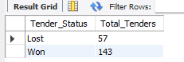
Business Insight
- Out of 200 tenders, 143 were won and 57 were lost.
- The overall win ratio is 71.5%, which indicates strong tender performance.
Recommendation
- Analyze lost tenders and implement corrective actions to improve future success rates.
Business Question
- How has the tender win ratio changed by year and quarter?
SQL Query
SELECT
Year(Tender_Date) AS Year,
quarter(Tender_Date) AS Quarter,
tender_status,
count(*) AS Total_Tender
FROM tender_master
GROUP BY
Year(Tender_Date),
quarter(Tender_Date),
Tender_Status
ORDER BY
Year,
Quarter;

Result
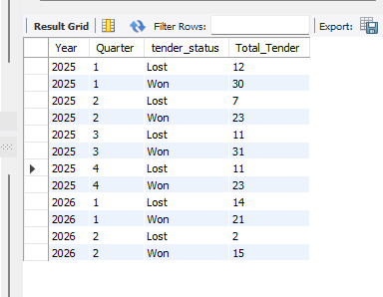

Business Insights
- Tender performance was stable during 2025 and remained above 70% in most quarters.
- The win ratio dropped from 67.65% in Q4 2025 to 60.00% in Q1 2026.
- This indicates a decline in tender performance and requires further investigation.
- Performance improved significantly in Q2 2026 with a win ratio of 88.24%.

Business Recommendation
- Review the tenders lost during Q1 2026 to identify possible reasons for the performance decline.
- Analyze successful tender strategies used in Q2 2026 and apply those practices to future tenders.
- Monitor win ratio quarterly and report any significant decline to senior management.

Business Question
- Which regions have the highest and lowest win ratio?
Business Problem
The company wants to know which regions are performing well and which regions need improvement. This will help the Tender Manager focus on low performing regions and improve the tender win ratio.
SQL Query
SELECT
Region,
COUNT(*) AS Total_Tender,
SUM(
CASE
WHEN Tender_Status = 'Won' THEN 1
ELSE 0
END
) AS Won_Tenders,
SUM(
CASE
WHEN Tender_Status = 'Lost' THEN 1
ELSE 0
END
) AS Lost_Tenders,
ROUND(
SUM(CASE
WHEN Tender_Status = 'Won' THEN 1
ELSE 0
END
) * 100.0 / COUNT(*),2
) AS Win_Ratio
FROM tender_master
GROUP BY Region
ORDER BY Win_Ratio DESC;

Result

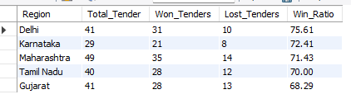

Insight

- Maharashtra has the highest win ratio.
- Karnataka has the lowest win ratio.
- The Tender Manager should review tender performance in Karnataka to identify improvement opportunities.

Remarks
- Review lost tenders in low-performing regions.
- Identify common reasons for tender loss.
- Apply successful strategies from high-performing regions.
- Monitor regional win ratio regularly.

Business Question
- Which Tender Categories perform best and worst?

Business Problem

The company wants to know which tender categories are performing well. This will help the company focus on successful categories and improve weaker categories.

SQL Query

SELECT
Tender_Category,
COUNT(*) AS Total_Tender,

SUM(
CASE
WHEN Tender_Status = 'Won' THEN 1
ELSE 0
END
) AS Won_Tenders,

SUM(
CASE
WHEN Tender_Status = 'Lost' THEN 1
ELSE 0
END
) AS Lost_Tenders,

ROUND(
SUM(
CASE
WHEN Tender_Status = 'Won' THEN 1
ELSE 0
END
) * 100.0 / COUNT(*),
2
) AS Win_Ratio

FROM tender_master

GROUP BY Tender_Category

ORDER BY Win_Ratio DESC;

Result
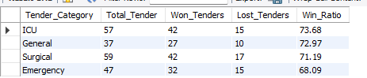

Business Insight
- ICU category has the highest win ratio at 73.68%
- General category also performed well with a win ratio of 72.97%.
- Emergency category has the lowest win ratio at 68.09%.
- All categories have a win ratio above 68%, which shows overall good tender performance.
Remarks

- ICU category achieved the highest win ratio of 73.68%, while Emergency category had the lowest win ratio of 68.09%.
- The company should review the Emergency category to improve future tender success.

User Story ID: US 02
Title: Tender Win Rate Analysis
Business Question
- Which states have the highest and lowest tender win rates?
Business Problem
The company wants to identify states with low tender win rates. This will help improve tender performance and increase business opportunities.
SQL Query

SELECT
Region,
COUNT(*) AS Total_Tender,

SUM(
CASE
WHEN Tender_Status = 'Won'
THEN 1
ELSE 0
END
) AS Tender_Won,

SUM(
CASE
WHEN Tender_Status = 'Lost'
THEN 1
ELSE 0
END
) AS Tender_Lost,
ROUND(
SUM(CASE WHEN Tender_Status = 'Won'
THEN 1
ELSE 0
END
) * 100.0/ COUNT(*) , 2
)
AS Win_ratio
FROM tender_master
group by Region
order by Win_ratio desc;

Result

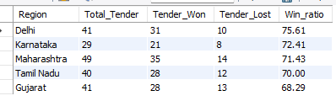

Insight
- Delhi is the best performing state in terms of tender win rate.
- Gujarat has the lowest tender win rate and may require further review to identify improvement opportunities.
Remarks

- Management should review Delhi's tender strategy and use it as a benchmark for other states.
- For Gujarat, management should review lost tenders and identify state-specific challenges. Improvement actions can then be developed based on the state's requirements and tender conditions.

Business Question
Which states contribute the highest and lowest tender value?

Business Problem
Currently, the company does not have visibility into state-wise tender value. The company wants to analyze tender value across different states. This analysis will help identify states that contribute higher and lower business value.

SQL Query

SELECT
Region,
SUM(Tender_Value) AS Total_Tender_Value
FROM tender_master
GROUP BY Region
ORDER BY Total_Tender_Value DESC;
Result
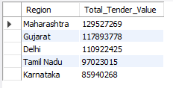

Business Insight

- Maharashtra contributes the highest tender value and accounts for 23.93% of the total tender value, making it an important business market for the company.

- Karnataka contributes the lowest tender value at 15.88%, indicating relatively lower business contribution compared to other states.

Remakes

- Management should continue strengthening its presence in Maharashtra to maintain business growth.

- Management should review business opportunities and tender participation in Karnataka to identify potential areas for improvement.

Business Question
- Which states have the highest and lowest number of tenders?

Business Problem

Company do not have a state wise visibility of tender tracking system.so company wanted to analysis tender opportunity as per state. Currently, company challenge in identifying business opportunities.

SQL Query

SELECT
Region,
COUNT(Tender_ID) AS Total_Tender
FROM tender_master
GROUP BY Region
ORDER BY Total_Tender DESC;

Result

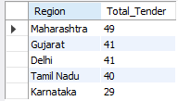

Business Insights

- Maharashtra has the highest number of tenders and contributes 24.5% of the company's total tender participation.
- However, the difference between Maharashtra and Gujarat, Delhi, and Tamil Nadu is only around 4%, indicating that tender activity is fairly balanced across these states.
- Karnataka contributes only 14.5% of total tenders, making it the state with the lowest tender participation.

Business Remarks
- Management should maintain strong participation in Maharashtra and review tender opportunities in Karnataka to identify potential growth areas.
- Additional focus should be placed on improving win rates and tender value in states with high tender participation.

Business Question

- How is the tender win rate changing quarter-wise across states?

Business Problem

Currently, management does not have visibility into changes in tender performance over time. The company wants to track quarter-wise performance across states. This analysis will help management identify performance trends and take action at the right time.

SQL Query

SELECT
YEAR(Tender_Date) AS Year,
QUARTER(Tender_Date) AS Quarter,

SUM(CASE WHEN Region = 'Delhi' THEN 1 ELSE 0 END) AS Delhi,
SUM(CASE WHEN Region = 'Gujarat' THEN 1 ELSE 0 END) AS Gujarat,
SUM(CASE WHEN Region = 'Karnataka' THEN 1 ELSE 0 END) AS Karnataka,
SUM(CASE WHEN Region = 'Maharashtra' THEN 1 ELSE 0 END) AS Maharashtra,
SUM(CASE WHEN Region = 'Tamil Nadu' THEN 1 ELSE 0 END) AS Tamil_Nadu

FROM tender_master

GROUP BY
YEAR(Tender_Date),
QUARTER(Tender_Date)

ORDER BY
YEAR(Tender_Date),
QUARTER(Tender_Date);
Result
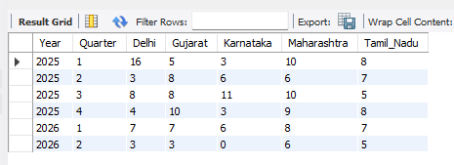

Business Insight

- In Q1 2026, all states except Karnataka showed lower tender volume compared to Q1 2025.
- Tender activity fluctuates across quarters, indicating changes in business opportunities over time.
- No consistent seasonal pattern is observed in tender volume across the analysed periods.
Remarks

- Management should investigate the decline in tender activity observed in Q1 2026.
- Quarterly performance should be monitored regularly to identify changes in business opportunities.
- Karnataka's performance should be reviewed to identify practices that may help improve participation in other states.

Business Question

- Which tender categories perform best and worst across states?

Business Problem

Currently, company does not have a visibility into tender performance by Government Type. The company wants to compare win rates between state government and central government tenders.

This analysis will help identify which government segment offers better tender success.

SQL Query
SELECT
Region,

SUM(
CASE
WHEN Government_Type = 'State Govt'
AND Tender_Status = 'Won'
THEN 1
ELSE 0
END
) AS State_Govt_Won,

SUM(
CASE
WHEN Government_Type = 'State Govt'
AND Tender_Status = 'Lost'
THEN 1
ELSE 0
END
) AS State_Govt_Lost,

SUM(
CASE
WHEN Government_Type = 'Central Govt'
AND Tender_Status = 'Won'
THEN 1
ELSE 0
END
) AS Central_Govt_Won,

SUM(
CASE
WHEN Government_Type = 'Central Govt'
AND Tender_Status = 'Lost'
THEN 1
ELSE 0
END
) AS Central_Govt_Lost

FROM tender_master

GROUP BY Region;

Result
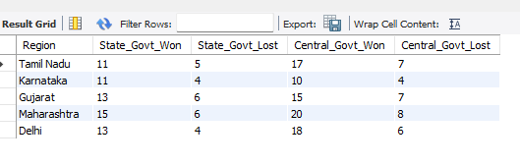

Business Insight

- Central and State Government tenders have a similar conversion ratio. However, Central Government tenders have a higher number of opportunities.

- Since the win ratio is similar, Central Government tenders may contribute more business opportunities due to the higher tender volume.

Remarks

- Review opportunities in Central Government tenders, as they account higher number of tender opportunities While maintain similar win ratio

User Story ID: US 03
Tender Margin Analysis

Business Question
- Which tenders have the highest and lowest winning margins?
Business Problem
Currently, the company does not have visibility into tender profitability. The company wants to analyse profit margin across tenders.

This analysis will help identify profitable and low-profit tenders for future business decisions.

SQL Query

SELECT
Tender_ID,
Sales_Amount,
Profit,

ROUND(
(Profit * 100.0) / Sales_Amount,
2
) AS Profit_Margin_avg

FROM sales_fact
order by
Profit_Margin_avg DESC
limit 1

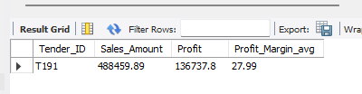

SELECT
Tender_ID,
Sales_Amount,
Profit,

ROUND(
(Profit * 100.0) / Sales_Amount,
2
) AS Profit_Margin_avg

FROM sales_fact
order by
Profit_Margin_avg ACE
limit 1
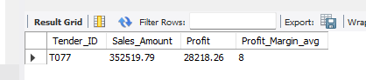

Business Insight

- Profit margin varies across tenders, indicating differences in profitability.
- The highest profit margin is 27.99%, while the lowest profit margin is 8%, showing that not all tenders contribute equally to business profitability.
Remarks
- Management should analyze the profit margin of tenders and focus on high-profit opportunities. This will support better bidding and business decisions.

Business Question

- Which states have the highest and lowest average profit margins?
Business Problem

Currently, the company does not have visibility into state profitability. The company wants to analyze geographical profitability. This analysis will help identify business opportunities across different states.

SQL Query

SELECT
tm.Region,

ROUND(
AVG((sf.Profit / sf.Sales_Amount) * 100),
2
) AS Avg_Profit_Margin

FROM sales_fact sf

INNER JOIN tender_master tm
ON sf.Tender_ID = tm.Tender_ID

GROUP BY tm.Region

ORDER BY Avg_Profit_Margin DESC;
Result

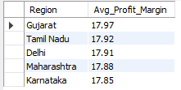

Business Insight

Profitability is relatively consistent across all states. Gujarat has the highest average profit margin of 17.97%, while Karnataka has the lowest average profit margin of 17.85%.

Remarks

Average profit margins are similar across all states. Since there is no significant difference in profitability, the company can focus on increasing tender participation to create more business opportunities.

Business Question

- Which tender categories have the highest and lowest average profit margins?

Business Problem

Currently, the company does not have visibility into profitability across tender categories. The company wants to analyze profit margin by tender category. his analysis will help identify profitable tender categories and support future bidding decisions.
SQL

SELECT
tm.tender_category,
ROUND(
AVG((sf.Profit / sf.Sales_Amount) * 100),
2
) AS Avg_Profit_Margin
FROM tender_master tm
INNER JOIN sales_fact sf
ON tm.Tender_ID = sf.Tender_ID
GROUP BY tm.Tender_Category
ORDER BY Avg_Profit_Margin DESC;

Result

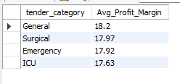

Business Insight
- Profitability is relatively similar across all tender categories. General category has the highest average profit margin of 18.20%, while ICU category has the lowest average profit margin of 17.63%.

Remark
- Average profit margins are similar across all categories. Management should consider other factors such as tender volume, tender value, and win rate while selecting future tender opportunities.

Business Question

- Which government type generates the highest and lowest average profit margins?

Business Problem

Management does not have visibility into tender profitability by government type.The company wants to analyze profit margins across different government types. This analysis will help identify more profitable government segments for future tender opportunities.

SQL Query
SELECT
tm.Government_Type,
ROUND(
AVG((sf.Profit / sf.Sales_Amount) * 100),
2
) AS Avg_Profit_Margin
FROM tender_master tm
INNER JOIN sales_fact sf
ON tm.Tender_ID = sf.Tender_ID
GROUP BY tm.Government_Type
ORDER BY Avg_Profit_Margin DESC;

Result

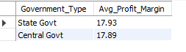

Business Insight

- Average profit margins for State Government and Central Government tenders are almost similar. State Government tenders have an average profit margin of 17.93%, while Central Government tenders have an average profit margin of 17.89%.
Remarks

- Since profit margins are similar, management should consider other factors such as tender volume, number of tenders, and business opportunities while making bidding decisions.

Business Question
- How is profitability changing over time?
Business Problem

- Currently, the company does not have visibility into profitability trends over time. Market conditions, product demand, and business expenses can change over time and impact profitability.

- The company wants to analyze profitability trends to identify changes in business performance and support future business decisions.
SQL Query
SELECT

YEAR(Invoice_Date) AS Year,

ROUND(
AVG(
CASE
WHEN QUARTER(Invoice_Date) = 1
THEN (Profit / Sales_Amount) * 100
END
),
2
) AS Q1,

ROUND(
AVG(
CASE
WHEN QUARTER(Invoice_Date) = 2
THEN (Profit / Sales_Amount) * 100
END
),
2
) AS Q2,

ROUND(
AVG(
CASE
WHEN QUARTER(Invoice_Date) = 3
THEN (Profit / Sales_Amount) * 100
END
),
2
) AS Q3,

ROUND(
AVG(
CASE
WHEN QUARTER(Invoice_Date) = 4
THEN (Profit / Sales_Amount) * 100
END
),
2
) AS Q4

FROM sales_fact

GROUP BY YEAR(Invoice_Date)

ORDER BY YEAR(Invoice_Date);

Result

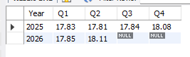

Business Insight
Profitability remained relatively stable across all quarters. No significant increase or decrease in average profit margin was observed during the analyzed period.

Business Remark

Management should maintain current profitability levels and focus on increasing tender participation to generate more business opportunities.

User Story ID: US 04
Title: State-wise Profitability Analysis

Business Question
- Which states generate the highest and lowest revenue?
Business Problem

Management does not have the visibility into contribution by state. The company want to analysis revenue across different states.

This analysis will help identify high-revenue and low-revenue states for future business opportunities.

SQL Query
SELECT
tm.Region,
ROUND(
SUM(sf.Sales_Amount) / 1000,
2
) AS Revenue_Thousand
FROM tender_master tm
INNER JOIN sales_fact sf
ON sf.Tender_ID = tm.Tender_ID
GROUP BY tm.Region

ORDER BY Revenue_Thousand

Result
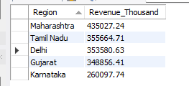

Business Insight

- Revenue contribution varies across states. Maharashtra generates the highest revenue of 435,027 thousand, while Karnataka generates the lowest revenue of 260,978 thousand.

Remarks

- Management should review the business strategy used in Maharashtra and identify opportunities to increase revenue in Karnataka and other low-revenue states.

Business Question

- Which states generate the highest and lowest profit?

Business Problem

Currently, the company does not have visibility into profit contribution by state.The company wants to analyze profit across different states. This analysis will help identify high-profit and low-profit states for future business opportunities.

SQL Query
SELECT
tm.Region,
ROUND(
SUM(sf.profit) ,
2
) AS Total_Profit
FROM tender_master tm
INNER JOIN sales_fact sf
ON sf.Tender_ID = tm.Tender_ID
GROUP BY tm.Region

ORDER BY Total_Profit DESC;

Result

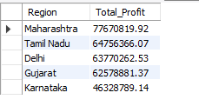

Insight
Profit contribution varies across states. Maharashtra generates the highest profit, while Karnataka generates the lowest profit.

Remarks
Management should focus on maintaining profitability in Maharashtra and review business challenges in Karnataka to improve profit performance.

Business Question
- How is state-wise revenue changing over time?
Business Problem

Revenue can change over time due to market conditions and business opportunities. The company wants to analyze state-wise revenue trends. This analysis will help identify growing and declining markets.

SQL Query

SELECT
YEAR(sf.Invoice_Date) AS Year,
QUARTER(sf.Invoice_Date) AS Quarter,
round(SUM(CASE WHEN tm.Region='Maharashtra'THEN sf.Sales_Amount ELSE 0 END)/1000,2) AS Maharashtra,
round(SUM(CASE WHEN tm.Region='Tamil Nadu' THEN sf.sales_Amount ELSE 0 END )/1000,2)AS Tamil_Nadu,
round(SUM( CASE WHEN tm.Region='Delhi'THEN sf. Sales_Amount ELSE 0 END )/1000,2)AS Delhi,
round(SUM( CASE WHEN tm.Region='Gujarat'THEN sf.Sales_Amount ELSE 0 END)/1000,2) AS Gujarat,
round(sum(CASE WHEN tm.Region='Karnataka' THEN sf.Sales_Amount ELSE 0 END)/1000,2)AS Karnataka
FROM sales_fact sf
JOIN tender_master tm
ON sf.Tender_ID = tm.Tender_ID
GROUP BY
YEAR(sf.Invoice_Date),
QUARTER(sf.Invoice_Date)
ORDER BY
YEAR(sf.Invoice_Date),
QUARTER(sf.Invoice_Date)

Result

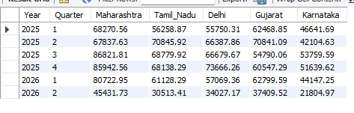
Business Insight

- Revenue performance varies across states and quarters.
- Revenue is relatively lower in Q1 compared to other quarters.
- Most states achieved higher revenue during 2025 Q3 and Q4, while 2026 Q1 revenue remained lower than most quarters of 2025.
Remarks
- Management should review the reasons for lower revenue in Q1 and identify opportunities to improve business performance during the beginning of the year.
- The strategies used during high-performing quarters such as Q3 and Q4 can be analyzed and replicated in future periods.

User Story ID: US 05
Title: Supplier Performance Analysis

Business Question

- Which suppliers have the highest and lowest ratings?

Business Problem

Currently, management is not able to track supplier performance effectively. The company wants to analyze supplier performance based on supplier ratings, delay counts, and compliance status.

This analysis will help identify high-performing and poor-performing suppliers and support supplier improvement decisions.

SQL Query

SELECT
Supplier_ID,
Supplier_Name,
Rating
FROM supplier_master

ORDER BY Rating ASC or DSCE

LIMIT 5;

Result

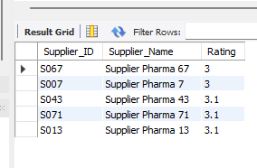

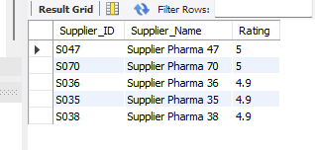

Business Insight

- Lowest rated suppliers have rating of 3 and 3.1. · Supplier Pharma 67 and Supplier Pharma 7 got the lowest rating of 3.
- Supplier Pharma 43, Supplier Pharma 71 and Supplier Pharma 13 got rating 3.1.
- Highest rated suppliers are Supplier Pharma 47 and Supplier Pharma 70 with rating 5.
- There is big difference between best and worst suppliers in the data.

Remarks
- Management should review the performance of low rated suppliers because they can cause delays in delivery and inventory problems.
- We need to check why Supplier Pharma 67 and Supplier Pharma 7 have low rating.
- Strategies used by high rated suppliers like Supplier Pharma 47 and Supplier Pharma 70 can be studied and followed by other suppliers.
- Regular supplier review every 3 months is important to improve tender performance and reduce risks.

Business Question

- Which suppliers have the highest and lowest delay counts?
Business Problem
Managemant does not have clear visibility on supplier delays. Management does not have clear visibility on supplier delays. This analysis will help the company to identify delays in operations caused by suppliers

SQL Query

SELECT  Supplier_Name,  Delay_Count  FROM supplier_master  ORDER BY Delay_Count DESC  LIMIT 7 | SELECT  Supplier_Name,  Delay_Count  FROM supplier_master  ORDER BY Delay_Count ASC  LIMIT 5
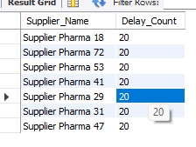 | 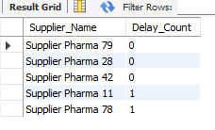

Business Insight

- Shortest Delay count is 0 (Zero). Supplier Pharma 28, Supplier Pharma 79, and Supplier Pharma 42 have None Dealy in given time period.
- Longest Delay count is 1. Supplier Pharma 28, Supplier Pharma 72, Supplier Pharma 53, Supplier Pharma 41, Supplier Pharma 29, Supplier Pharma 31 and Supplier Pharma 47

Remarks
- Management should continue working with high-rated suppliers and review low-rated suppliers for quality, delivery, and service issues. Improvement plans should be implemented to enhance supplier performance.

Business Question
- How are suppliers distributed across compliance statuses?

Business Problem

Currently, the company does not have visibility into supplier compliance status.The company wants to analyze supplier compliance status.This analysis will help support supplier selection decisions.

SQL Query

SELECT
Compliance_Status,
COUNT(*) AS Supplier_Count
FROM supplier_master
GROUP BY Compliance_Status;

Result
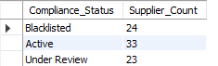

Business Insight

Supplier compliance status varies across suppliers. Out of 80 suppliers, only 33 suppliers are Active, while 47 suppliers are either Blacklisted or Under Review. This indicates that a significant number of suppliers require review or corrective action.

Remark

Management should prioritize Active suppliers for business operations and review Blacklisted and Under Review suppliers to identify compliance issues and improvement opportunities.

Business Question

- How are supplier ratings distributed?

Business Problem

Management does not have visibility into the overall quality of suppliers. The company wants to analyze supplier ratings. This analysis will help understand the distribution of supplier performance and support supplier evaluation decisions.

SQL Query

SELECT
CASE
WHEN Rating >= 4.5 THEN 'Excellent'
WHEN Rating >= 4.0 THEN 'Good'
WHEN Rating >= 3.5 THEN 'Average' ELSE 'Poor'END AS Rating_Category,
COUNT(*) AS Supplier_Count
FROM supplier_master
GROUP BY Rating_Category;

Result
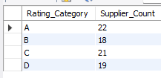

Insight

Supplier ratings are distributed across all rating categories. The highest number of suppliers belong to Category A (22 suppliers), while Category D contains 19 suppliers. This indicates that supplier performance varies significantly across the supplier base.
Remark
Management should prioritize Category A suppliers for future business opportunities and review Category D
suppliers to identify performance improvement opportunities. Category B and C suppliers should be monitored regularly to improve overall supplier performance.

User Story ID: US 06
Title: Inventory Risk Monitoring

Business Question

- Which medicines are below the reorder level?
Business Problem
Company does not have visibility into low stock medicines. The company wants to compare current stock with reorder levels. This will help identify medicines that need to be reorder.

SQL Query
select
Medicine_ID,
Medicine_Name,
Category,
Stock_Qty,
Reorder_Level,
(Reorder_Level - Stock_Qty) AS Shortage_Quantity
from medicine_inventory
where Stock_Qty < Reorder_Level
order by Shortage_Quantity desc

Result
Medicine_ID | Medicine_Name | Category | Stock_Qty | Reorder_Level | Shortage_Quantity
M147 | Insulin 147 | Injection | 379 | 2613 | 2234
M349 | Cough Syrup 349 | Syrup | 684 | 2773 | 2089
M058 | Amoxicillin 58 | Injection | 415 | 2404 | 1989
M117 | Azithromycin 117 | Capsule | 417 | 2364 | 1947
M078 | Ibuprofen 78 | Capsule | 946 | 2261 | 1315
M164 | Omeprazole 164 | Injection | 593 | 1898 | 1305
M033 | Metformin 33 | Tablet | 323 | 1609 | 1286
M259 | Metformin 259 | Tablet | 1504 | 2730 | 1226
M382 | Amoxicillin 382 | Capsule | 570 | 1765 | 1195
M369 | Metformin 369 | Injection | 991 | 2139 | 1148
M063 | Azithromycin 63 | Tablet | 149 | 1284 | 1135
M273 | Vitamin D 273 | Syrup | 547 | 1621 | 1074
M222 | Cough Syrup 222 | Injection | 1214 | 2150 | 936
M088 | Cough Syrup 88 | Capsule | 1711 | 2597 | 886
M021 | Amoxicillin 21 | Syrup | 2137 | 2995 | 858
M091 | Metformin 91 | Injection | 2086 | 2869 | 783
M281 | Paracetamol 281 | Tablet | 362 | 1107 | 745
M178 | Omeprazole 178 | Tablet | 2207 | 2948 | 741
M315 | Omeprazole 315 | Injection | 728 | 1451 | 723
M014 | Metformin 14 | Syrup | 1156 | 1819 | 663
M366 | Paracetamol 366 | Syrup | 670 | 1235 | 565
M268 | Metformin 268 | Tablet | 1946 | 2415 | 469
M160 | Insulin 160 | Capsule | 2001 | 2438 | 437
M093 | Metformin 93 | Injection | 1968 | 2393 | 425
M267 | Azithromycin 267 | Injection | 1033 | 1448 | 415
M235 | Metformin 235 | Injection | 367 | 615 | 248
M275 | Amoxicillin 275 | Tablet | 2410 | 2620 | 210
M118 | Omeprazole 118 | Syrup | 1883 | 2084 | 201
M062 | Insulin 62 | Syrup | 885 | 1081 | 196
M180 | Metformin 180 | Tablet | 2111 | 2286 | 175
M177 | Amoxicillin 177 | Tablet | 1095 | 1263 | 168
M084 | Cough Syrup 84 | Injection | 1454 | 1581 | 127
M285 | Azithromycin 285 | Syrup | 724 | 795 | 71

Business Insight
33 medicine are now below the reorder level, indicating risk of stock shortage, several medicines have significant shortage quantity, which may medicine availability if replenishment is delayed.

Remark
The company should replenish medicines with high shortage quantities on priority to maintain stock availability and avoid inventory issues.
Business Question
- Which medicines are nearing expiry?

Business Problem
The company does not have visibility into medicines that are nearing expiry. The company wants to analyze medicine expiry dates. This analysis will help reduce medicine wastage, lower inventory costs, and improve profitability.

SQL Query

SELECT
Medicine_ID,
Medicine_Name,
Category,
Expiry_Date,

DATEDIFF(
Expiry_Date,
CURDATE()
) AS Days_To_Expiry

FROM medicine_inventory

WHERE DATEDIFF(
Expiry_Date,
CURDATE()
) BETWEEN 0 AND 90

ORDER BY Days_To_Expiry;

Result

Medicine_ID | Medicine_Name | Category | Expiry_Date | Days_To_Expiry
M334 | Vitamin D 334 | Capsule | 15-06-2026 | 0
M055 | Paracetamol 55 | Capsule | 16-06-2026 | 1
M135 | Cough Syrup 135 | Injection | 18-06-2026 | 3
M136 | Amoxicillin 136 | Capsule | 18-06-2026 | 3
M110 | Vitamin D 110 | Injection | 22-06-2026 | 7
M337 | Cough Syrup 337 | Capsule | 22-06-2026 | 7
M174 | Vitamin D 174 | Syrup | 23-06-2026 | 8
M236 | Vitamin D 236 | Tablet | 27-06-2026 | 12
M098 | Cough Syrup 98 | Syrup | 01-07-2026 | 16
M119 | Metformin 119 | Injection | 01-07-2026 | 16
M050 | Amoxicillin 50 | Capsule | 03-07-2026 | 18
M123 | Cetirizine 123 | Tablet | 04-07-2026 | 19
M289 | Vitamin D 289 | Tablet | 05-07-2026 | 20
M205 | Insulin 205 | Syrup | 11-07-2026 | 26
M166 | Vitamin D 166 | Tablet | 12-07-2026 | 27
M035 | Cough Syrup 35 | Syrup | 13-07-2026 | 28
M100 | Omeprazole 100 | Syrup | 18-07-2026 | 33
M032 | Ibuprofen 32 | Capsule | 21-07-2026 | 36
M318 | Cetirizine 318 | Tablet | 22-07-2026 | 37
M054 | Cetirizine 54 | Capsule | 22-07-2026 | 37
M359 | Amoxicillin 359 | Tablet | 22-07-2026 | 37
M386 | Paracetamol 386 | Capsule | 23-07-2026 | 38
M229 | Cetirizine 229 | Capsule | 23-07-2026 | 38
M264 | Cetirizine 264 | Capsule | 26-07-2026 | 41
M336 | Omeprazole 336 | Capsule | 28-07-2026 | 43
M114 | Vitamin D 114 | Injection | 31-07-2026 | 46
M340 | Azithromycin 340 | Capsule | 04-08-2026 | 50
M094 | Cough Syrup 94 | Tablet | 05-08-2026 | 51
M265 | Vitamin D 265 | Injection | 08-08-2026 | 54
M195 | Metformin 195 | Tablet | 15-08-2026 | 61
M320 | Ibuprofen 320 | Tablet | 16-08-2026 | 62
M137 | Vitamin D 137 | Injection | 16-08-2026 | 62
M167 | Omeprazole 167 | Tablet | 16-08-2026 | 62
M168 | Cetirizine 168 | Syrup | 17-08-2026 | 63
M045 | Cough Syrup 45 | Tablet | 18-08-2026 | 64
M009 | Omeprazole 9 | Injection | 20-08-2026 | 66
M126 | Cough Syrup 126 | Tablet | 29-08-2026 | 75
M192 | Azithromycin 192 | Syrup | 29-08-2026 | 75
M107 | Ibuprofen 107 | Syrup | 29-08-2026 | 75
M075 | Omeprazole 75 | Syrup | 29-08-2026 | 75
M012 | Amoxicillin 12 | Capsule | 31-08-2026 | 77
M345 | Azithromycin 345 | Syrup | 07-09-2026 | 84
M127 | Metformin 127 | Capsule | 08-09-2026 | 85

Business Insight

Several medicines are nearing expiry within the next 90 days. This may create a risk of medicine wastage and inventory loss.

Business Remarks

The company should monitor medicines nearing expiry and take action to use or distribute them before the expiry date.

Business Question
- Which medicines require immediate action?

Business Insights
The company does not have visibility into medicines that require immediate action. The company wants to identify medicines with inventory risks. This analysis will help prevent stock shortages and reduce inventory loss.

SQL Query
SELECT
Medicine_ID,
Medicine_Name,
Category,
Stock_Qty,
Reorder_Level,
Expiry_Date,

DATEDIFF(
Expiry_Date,
CURDATE()
) AS Days_To_Expiry

FROM medicine_inventory

WHERE Stock_Qty < Reorder_Level
OR DATEDIFF(Expiry_Date, CURDATE()) BETWEEN 0 AND 90

Business Insight

Some medicines are below the reorder level and are nearing expiry. These medicines require immediate attention because they may create stock shortages and medicine wastage.

Remarks

The company should review these medicines on priority and take action to replenish, transfer, or use the stock before the expiry date.

Business Question

- Which medicine categories have the highest inventory risk?

Business Problem

The company does not have visibility into inventory risk across medicine categories. The company wants to analyze inventory risks by medicine category. This analysis will help identify categories that require additional inventory monitoring.

SQL Query

SELECT
Category,
COUNT(*) AS Low_Stock_Medicines
FROM medicine_inventory
WHERE Stock_Qty < Reorder_Level
GROUP BY Category
ORDER BY Low_Stock_Medicines DESC;

Result

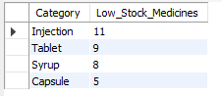

Business Insights

Some medicine categories have more low-stock medicines compared to others. This indicates higher inventory risk in those categories.

Business Remarks
The company should regularly monitor these categories and place purchase orders on time. Maintaining sufficient stock will help avoid medicine shortages and support smooth business operations.

User Story ID: US 07
Title: Delivery Performance Monitoring

Business question
- How many deliveries were delayed?

Business Problem
The company wants to identify the numbers of delayed deliveries. This will help to analyse delivery performance and identify operational issues.

SQL Query
SELECT
Delivery_Status,
count(*) AS Number_Deliveries
from delivery_tracking
Group By Delivery_Status

Result
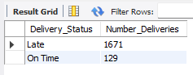

Business Insight
Out of 1800 deliveries,1671 were delivered late and only 129 delivered on time. This shows that delivery performance is poor and most deliveries are not reaching customers as planned.

Business Remark

The company should review the delivery process and identify the reasons for the delays. improving dispatch planning and logistics operations can help increase on time deliveries

Business Question
- What is average delivery delay?
Business Problem
The company does not have visibility on average number of delay days. This will help evaluate delivery efficiency and monitor service level.

SQL Query

SELECT
avg(Delay_Days) as AVG_Delivery_Delay
from delivery_tracking

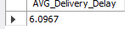

Business insight

The average delivery delay is 6.1 days. This indicates that delayed deliveries are typically delivered almost one week after the expected delivery date.

Business Remark

The company should review logistics, dispatch planning, and transportation processes to reduce delivery delays and improve customer service levels.

Business Question

- Which states have the highest and lowest delivery delays?

SQL Query

SELECT  dt.Delivery_ID,  dt.Tender_ID,  dt.Delay_Days,  tm.Region  FROM delivery_tracking dt  INNER JOIN tender_master tm  ON dt.Tender_ID = tm.Tender_ID  ORDER BY dt.Delay_Days DESC | SELECT  dt.Delivery_ID,  dt.Tender_ID,  dt.Delay_Days,  tm.Region  FROM delivery_tracking dt  INNER JOIN tender_master tm  ON dt.Tender_ID = tm.Tender_ID  ORDER BY dt.Delay_Days ASC

Result

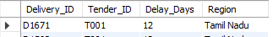 | 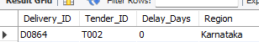

Business Insight

Delivery delays ranged between 0 and 12 days. While some deliveries were completed on time, a few deliveries experienced delays of up to 12 days, indicating opportunities to improve logistics and delivery planning.

Remarks
The company should investigate deliveries with high delay days and identify the root causes. Improving transportation planning and delivery monitoring can help reduce future delays.

Business Problem

The company wants to identify states with poor delivery performance. This analysis will help logistic manager focus on regions that required performance.

Business Question
- Which states have the highest and lowest average delivery delays?
Business Problem
The company does not have visibility into state-wise delivery performance. The company wants to identify states with the highest and lowest average delivery delays. This analysis will help evaluate delivery processes across different states, identify operational issues, and reduce future delivery delays.

SQL Query
SELECT
tm.Region,
ROUND(AVG(dt.Delay_Days),2) AS Avg_Delay_Days
FROM delivery_tracking dt
INNER JOIN tender_master tm
ON dt.Tender_ID = tm.Tender_ID
GROUP BY tm.Region
ORDER BY Avg_Delay_Days DESC;

Result
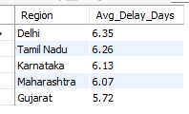

Insight Business

Average delivery delays are similar across all states. Delhi has the highest average delay of 6.35 days, while Gujarat has the lowest average delay of 5.27 days. Since the difference is small, delivery delays appear to be affecting all states in a similar manner.

Remarks

Management should review the overall delivery process, including dispatch planning and transportation activities, because delivery delays are occurring across all states. Improving the end-to-end logistics process may help reduce average delivery delays.

User Story ID: US 08
Title Payment Collection Monitoring

Business Question

- What is the total pending payment amount?

Business Problem

The Finance Manager does not have visibility into the total outstanding payment amount. This analysis will help assess cash flow risk and monitor pending collections.

SQL Query

SELECT
ROUND(SUM(Due_Amount)/1000,2) AS Total_Pending_Amount
FROM payment_tracking
WHERE Payment_Status = 'Pending';
Result

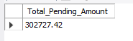

Business Insight
The total pending payment amount is 302,727.42. This indicates a significant amount of outstanding receivables that have not yet been collected from hospitals. A high pending amount may impact the company's cash flow and working capital management.

Remark
The Finance team should regularly monitor pending payments and team should implement a payment reminder and tracking system to improve collection performance.

Business Question
- How many invoices are pending payment?

Business Problem

The Finance Manager does not have visibility into the number of pending invoices. This analysis will help track collection workload and support payment follow-up activities.

SQL Query

SELECT
SUM(CASE
WHEN Payment_Status = 'Pending' THEN 1
ELSE 0
END) AS Total_Outstanding_Invoice
FROM payment_tracking;

Result
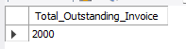

Business Insights

During the 15-month period, 2,000 invoices are still pending for payment. This indicates a significant collection backlog and may impact the company's cash flow.

Remark

The Finance team should prioritize payment follow-ups and regularly monitor pending invoices. A structured collection process can help reduce outstanding payments and improve cash flow.

Business Question
- Which hospitals have the highest pending payment amounts?

Business Problem
The company does not know which hospitals contribute the highest outstanding balances. This analysis will help prioritize collection efforts and reduce financial risk.

SQL Query

SELECT
Hospital_Name,
ROUND(SUM(Due_Amount),2) AS Pending_Amt
FROM payment_tracking
WHERE Payment_Status = 'Pending'
GROUP BY Hospital_Name
ORDER BY Pending_Amt DESC;

Result

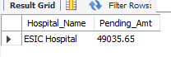
Business Insight

ESIC Hospital has the highest pending payment amount of 49,035.65. This indicates that a significant portion of the company's outstanding receivables is concentrated with a single hospital. Delayed payment collection from this hospital may negatively impact cash flow and working capital management.

Remarks
The Finance team should prioritize payment follow-ups with ESIC Hospital and closely monitor high-value outstanding invoices. Timely collection of pending payments will help improve cash flow and reduce financial risk.

Business Question
- Which invoices have the highest pending amounts?

Business Problem
Management wants to identify high-value pending invoices that require immediate attention.

SQL Query

SELECT
Invoice_ID,
Hospital_Name,
SUM(Due_Amount) AS Pending_Amount
FROM payment_tracking
WHERE Payment_Status = 'Pending'
GROUP BY Invoice_ID, Hospital_Name
ORDER BY Pending_Amount DESC LIMIT 1;

Result
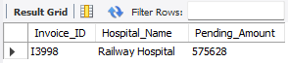

Business Insight
Invoice I3998 from Railway Hospital has the highest pending payment amount of 575,628. This indicates that a significant portion of the company's outstanding receivables is associated with a single invoice. Delayed collection of this payment may negatively impact the company's cash flow and working capital.
Remark

The Finance team should prioritize follow-up activities for Invoice I3998 and coordinate with Railway Hospital to expedite payment collection. Regular monitoring of high-value pending invoices can help reduce financial risk and improve cash flow management.

Business Insight
- Which hospitals have the highest number of pending invoices?

Business Problem

Some hospitals may repeatedly delay payments. The company wants to identify hospitals with multiple pending invoices.
SQL Query

SELECT
Hospital_Name,
COUNT(Invoice_ID) AS Pending_Invoices
FROM payment_tracking
WHERE Payment_Status = 'Pending'
GROUP BY Hospital_Name
ORDER BY Pending_Invoices DESC
LIMIT 1;

Result

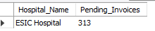

Insight Business

ESIC Hospital has the highest number of pending invoices with 313 invoices. This shows that payments from this hospital are not being collected on time and may affect the company's cash flow.

Remarks

The Finance team should regularly follow up with ESIC Hospital and monitor pending invoices to improve payment collections.

